“terminated employees (e.g., 10664090, 10556054) still appeared as active in Healthtime”
for 10664090, the action_dt was 2025-10-20 which was 5 days after termination_dt 2025-10-15.
The terminated record was in the integration file 2025-10-21.
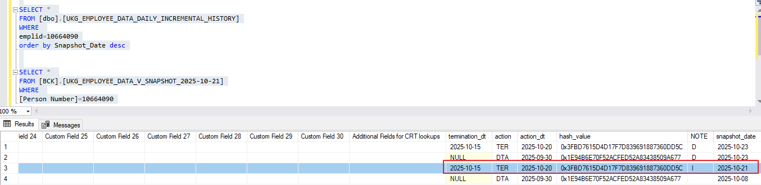
for 10556054, the action_dt was 2025-10-16 which was 2 days after termination_dt 2025-10-14.
The terminated record was in the integration file 2025-10-17.
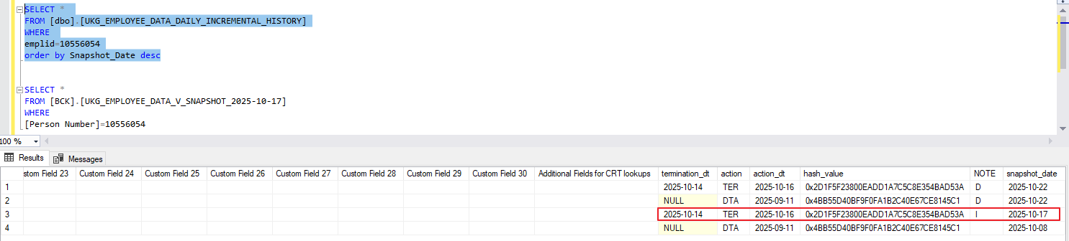

I can set up an email notification for you whenever this kind of situation happens.

